FACT SHEET

Increased sowing density with appropriate fertilizer
Innovation Lab (submitting technology): Sustainable Intensification Innovation Lab
Author(s): Aliou Faye, Zachary Stewart and Vara Prasad Location: Bambey satellite (Senegal)
Submission Group: 1 (Phase of Technology: #4)

Brief Description
Sustainable intensification (SI) of agriculture production is required to address food and nutrition insecurity in West Africa. Significant millet production increase is possible through increasing sowing density (24 692 seed hills ha-1) with appropriate fertilizer application as compared to far-mer practice of 12 346 seed hills ha-1 .with flat fertilizer recommendation. With the country flat recommendation of 150 kg/ha of NPK (68,5- 22,5-22,5) + 100kg/ha urea at flowering, old millet variety (Souna 3) grain yield increase at least by 100% while improved millet variety Thialack 2 yield reach over 150%. These increases are again much better when fertilizer amount is enhanced at NPK 90-13-9.

Technical Performance/Technical Characteristics

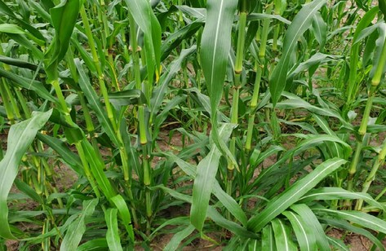
Increased sowing density with fertilizer Photo credit: Aliou Faye, ISRA

This technology demonstrated in 3 millet cropping zones of Senegal (Bambey, Nioro, and Sinthiou Malem) during 3 successive years shows that increasing sowing density at 24.692 seed hills ha-1 (0.90m*0.45m) allows an increase of more than 30% in grain yield and straw yield compared to 12.346 seed hills ha-1 (0.90m*0.90m). In other words, this allows for more grain yield production without increasing land area, regardless of the millet variety and the location.

Price to Customers
No information

Socio-economic Performance/Economic Profitability
Increased sowing density improved grain and fodder yield by 100% to 150%
Increased sowing density improved revenue and the economic profitability compared with the farmer’s practice
Low-cost technology for farmers

FACT SHEET

Increased sowing density with appropriate fertilizer

Instructional Care of Technology
Seeding density: 24,692 seed hill ha-1 (0.90m*0.45m) Seeding period: early July
Soil preparation: Consists primarily of eliminating crop residues that can likely spread diseases and serve as a refuge for pests. In light soils, this cleaning followed by a superficial scarification is often done after the first light rain; this allows elimination of weeds and loosens the surface layer of the soil where the seeds will be sown after the first useful rain. In wetter areas or on heavier soils, ploughing early is recommended to eliminate the first weeds and loosen the soil which is refined by harrowing
Suitable area: All agroecological zones in Senegal
Fertilization: 150 kg/ha of NPK (15-15-15) + 50 kg/ha urea (46% N) at 15-21 days after sowing with an additional 50 kg/ha urea (46% N) at 45 days after sowing
Weeding: Is necessary for growth and allows better infiltration of rainwater, controls young weeds and helps avoid competition for water resources, which are often limited in the Sahelian areas. This first weeding is generally followed by one or two others according to demand, coupled with manual weeding within the row Phytosanitary protection: Phytosanitary protection must be perpetual. In case of attack, adequate treatment must be applied
Harvest: Millet panicles and stover should be hand harvested at physiological maturity

Climate Mitigation Information
No information

Impact Pathway & Potential Scaling Partners
CORAF Scaling Model as an example; however, if the Innovation Lab has a model already in use, please use that model. Please provide specific names for scaling partners.
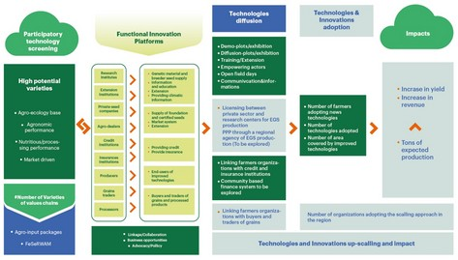

Contact persons:
Aliou Faye: aliouselbe11@gmail.com; aliouselbe11@yahoo.fr Zachary P. Stewart: zastewart@usaid.com
P.V. Vara Prasad: vara@ksu.edu

Contacts affiliated institutions:
ISRA - CERAAS (Thiès)
Bureau for Resilience and Food Security Kansas State University

