FACT SHEET

Improved Peanut Varieties
(Raw Gadu and Sunu Gaal)
Innovation Lab (submitting technology): Peanut Innovation Lab Author(s): Issa Faye, Aissatou Sambou and Daniel Fonceka ATP Location(s): Bambey satellite (Senegal)
Submission Group: 1 (Phase of Technology: #4)

Brief Description
Peanut is the main cash crop of Senegal but continues to face challenges related to low yield
as a consequence of low soil fertility and low, erratic rainfall. In response, the Senegalese Institute of Agricultural Research (ISRA) in collaboration with international organizations such as CGIAR, CIRAD, IRD and the Peanut Innovation Lab (PIL) work together to bred new peanut
varieties that are more productive, more adapted and more resilient in the current climate change. The two improved varieties (i.e. Raw Gadu and Sunu Gaal) were bred with the objective of better yield in both grain and fodder and more adapted to the peanut basin context (drought, low soil
fertility).

Technical Performance/Technical Characteristics

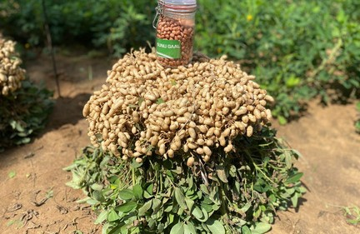
Improved peanut varieties (Sunu Gaal) Photo credit: Aliou Faye, ISRA

The main characteristics of the improved varieties (Raw Gadu and Sunu Gaal) offers a larger size and results in higher yield potential (2.5 t/ha-1 for Raw Gadu and 3 t/ha-1 for Sunu Gaal) than the well-known Fleur 11 (<2t/ha-1). Fodder yield is also important and yields over 3 t/ha-1 while that of the Fleur 11 is around 2
t/ha-1. In addition, the improved varieties have more oil content (over 45%).

Price to Customers
Same as old and well-known varieties

Socio-economic Performance/Economic Profitability
Improved varieties increased grain and fodder yield by 30-50% More tolerate to drought
Improved varieties have bigger grain size, better weight, and economic profitability

Instructional Care of Technology

FACT SHEET

Improved Peanut Varieties
(Raw Gadu and Sunu Gaal)

Seeding density: 135 000 plants ha-1 (0.5m*0.15m for both varieties) Seeding period: During the winter period (from July to September)
Soil preparation: Consists primarily of eliminating crop residues that can likely spread diseases and serve as a refuge to pests. In light soils, this cleaning is followed by a superficial scarification and is often done after the first light rain. This allows for elimination of the first weeds and loosens the surface layer of the soil where the seeds will be sown following the first useful rain. In wetter areas or on heavier soils, ploughing early is recommended to eliminate the weeds and loosen the soil which is then refined by harrowing
Suitable area: Groundnut basin (well distributed 400-600 mm are sufficient) Fertilization: 150 kg/ha-1 of NPK (6-20-10) at 15-21 days after sowing
Weeding: Is necessary for growth and allows better infiltration of rainwater, controls young weeds and helps avoid competition for water resources, which are often limited in the Sahelian areas. This first weeding is generally followed by one or two others according to demand, coupled with manual weeding within the row Phytosanitary protection: Peanuts are exposed to disease and pest attacks that can cause significant losses and deterioration of the quality of the production. The recommended control methods against diseases and insects must be followed during the cropping season.
Harvest: Can be done as soon as 70-80% of the pods are mature

Climate Mitigation Information
No information provided

Impact Pathway & Potential Scaling Partners
CORAF Scaling Model as an example; however, if the Innovation Lab has a model already in use, please use that model. Please provide specific names for scaling partners.
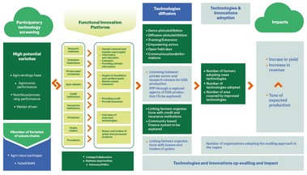

Contact persons
Dr Aissatou Sambou: sambou.aissatou@yahoo.fr Idrissa Faye: issafaye2001@gmail.com
Daniel fonceka: daniel.fonceka@cirad.fr
Contacts affiliated institutions ISRA - CERAAS (Thiès) ISRA - CNRA (Bambey)
CIRAD (Thies)

